Data Interpretation Exercise

Question 1: Mapping Data onto Aesthetics
R Program:
library(ggplot2)

sales_data <- data.frame(
Product = c("P1","P2","P3","P4","P5","P6"),
Sales = c(120, 90, 150, 80, 135, 100),
Profit = c(18, 12, 25, 8, 22, 16),
Category = c("Electronics","Clothing","Electronics",
"Furniture","Furniture","Clothing")
)

ggplot(sales_data, aes(x = Sales, y = Profit)) +
geom_point(aes(color = Category, size = Sales), alpha = 0.85) +
labs(title = "Sales vs Profit by Category",
x = "Sales (Rs. Lakhs)", y = "Profit (%)") +
theme_minimal()
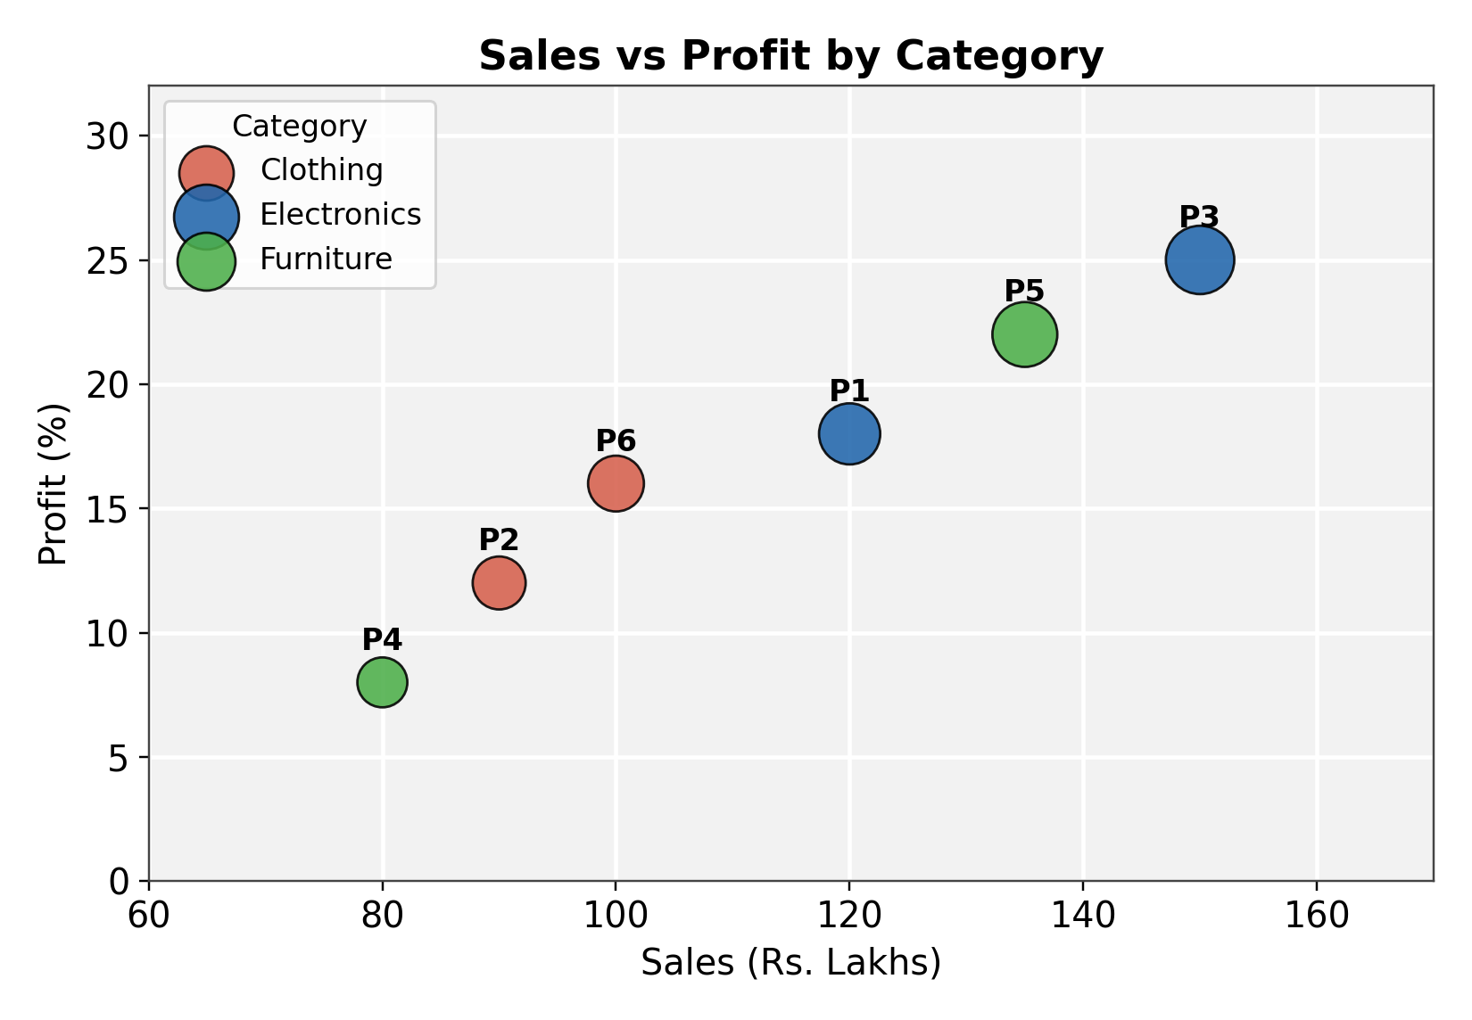
Fig 1.1: Scatter plot of Sales vs Profit, coloured by Category
Answers:
Interpret the relationship between Sales and Profit.
The scatter plot shows a clear positive relationship between Sales and Profit: as Sales increase, Profit percentage also tends to increase. Products P3 and P5, which have the highest sales (150 and 135 Lakhs), also record the highest profit margins (25% and 22%). In contrast, P4, with the lowest sales (80 Lakhs), also has the lowest profit (8%). The Electronics category (P1, P3) and Furniture category (P4, P5) show the widest spread in both sales and profit, while Clothing (P2, P6) sits in the middle range on both axes.
Identify the type of scale used for each variable.
Sales and Profit are both plotted on the x and y axes respectively, and since both take numeric values that can range continuously, they use a continuous scale. Category, on the other hand, takes only a few fixed text labels (Electronics, Clothing, Furniture), so it is mapped using a discrete (categorical) colour scale, where each category is assigned its own distinct colour rather than a position along a numeric range.
Suggest one alternative visualization that better represents the same data.
A grouped/faceted bar chart showing Profit for each Product, arranged and coloured by Category, would also work well for this data. It would be especially useful if the goal is to compare individual products side by side rather than to see the overall sales-profit trend, since bar charts make exact value comparisons across categories easier to read than bubble size differences.

Question 2: Coordinate Systems (Cartesian and Polar)
R Program (Cartesian):
library(ggplot2)

wind_data <- data.frame(
Direction = c("N","NE","E","SE","S","SW","W","NW"),
Frequency = c(18, 12, 20, 15, 22, 11, 16, 14)
)
wind_data$Direction <- factor(wind_data$Direction,
levels = c("N","NE","E","SE","S","SW","W","NW"))

ggplot(wind_data, aes(x = Direction, y = Frequency)) +
geom_bar(stat = "identity", fill = "steelblue") +
labs(title = "Wind Direction Frequency - Cartesian",
x = "Direction", y = "Frequency") +
theme_minimal()
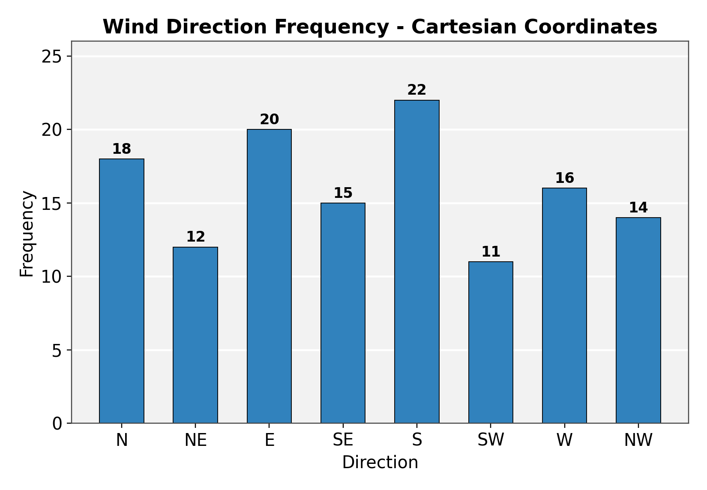
Fig 2.1: Cartesian bar chart of wind direction frequency
R Program (Polar):
ggplot(wind_data, aes(x = Direction, y = Frequency)) +
geom_bar(stat = "identity", fill = "steelblue") +
coord_polar(start = 0) +
labs(title = "Wind Direction Frequency - Polar") +
theme_minimal()
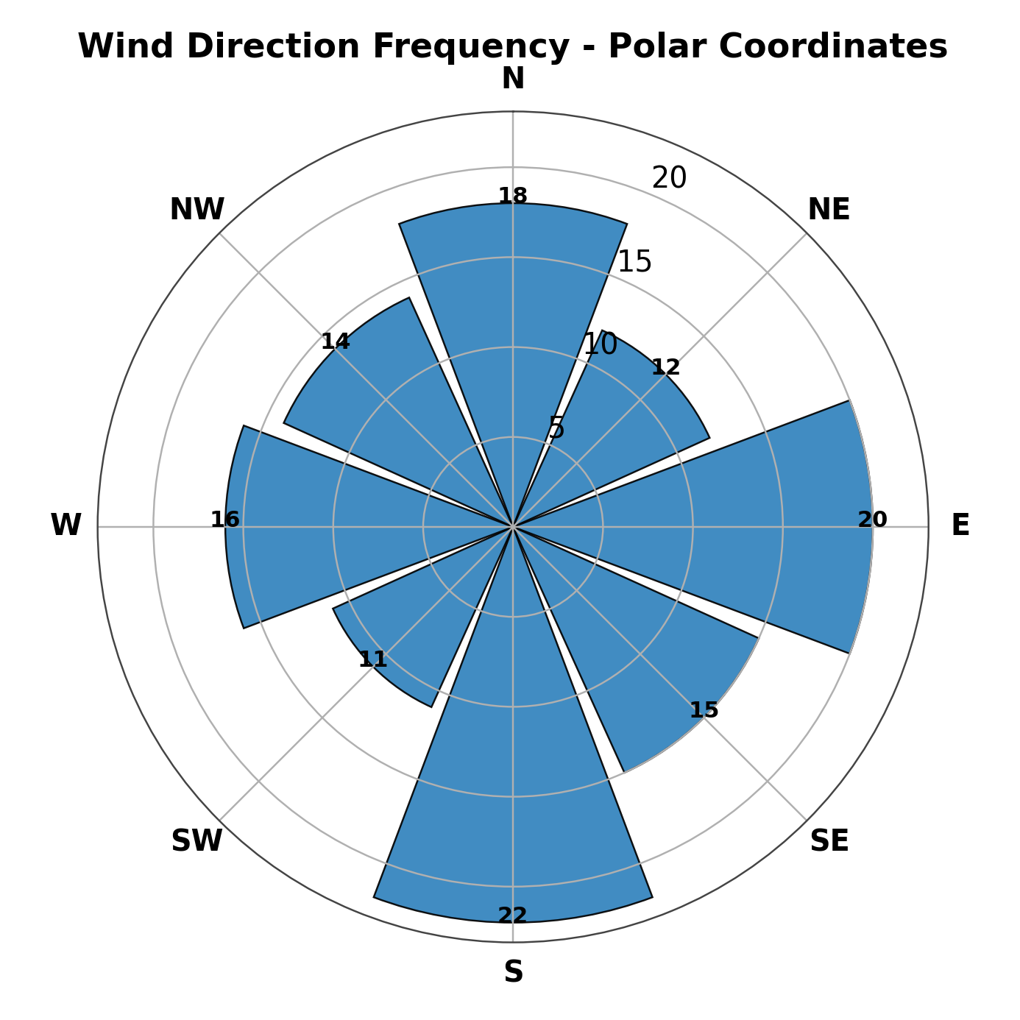
Fig 2.2: Polar (wind-rose) chart of wind direction frequency
Answers:
Compare the effectiveness of both visualizations.
The Cartesian bar chart makes it easy to read exact frequency values and compare bar heights precisely along a straight axis, which is useful for quick numeric comparison. The polar chart, however, arranges the same values around a circle in a way that mirrors real compass directions, making the overall directional pattern -- where frequency is concentrated and how it flows around the compass -- much more intuitive to grasp visually, even though exact values are slightly harder to read off a circular axis.
Explain which coordinate system is more appropriate for directional data.
The polar coordinate system is more appropriate for directional data such as compass direction. This is because direction is inherently circular and angular rather than linear -- North follows Northwest just as naturally as it precedes Northeast -- and a polar layout preserves this circular relationship visually, whereas a Cartesian bar chart forces the directions into an arbitrary straight-line order that breaks the natural adjacency between, for example, NW and N.
Justify your answer based on data interpretation.
Because the polar chart maps each compass direction to its actual angular position, a viewer can instantly see, for instance, that frequency is highest in the S-E-N cluster and lower in the SW-NE cluster, matching real-world orientation. This kind of spatial insight is lost in the Cartesian version, where the same information is presented as a flat sequence of bars with no inherent geographic meaning, making the polar chart the more interpretively faithful choice for this dataset.

Question 3: Color Scales for Data Representation
R Program:
library(ggplot2)

marks_data <- data.frame(
Student = c("A","B","C","D","E","F"),
Marks = c(45, 58, 72, 81, 67, 90)
)

ggplot(marks_data, aes(x = Student, y = Marks, fill = Marks)) +
geom_bar(stat = "identity") +
scale_fill_gradient(low = "lightblue", high = "darkblue") +
labs(title = "Student Marks - Sequential Color Scale") +
theme_minimal()
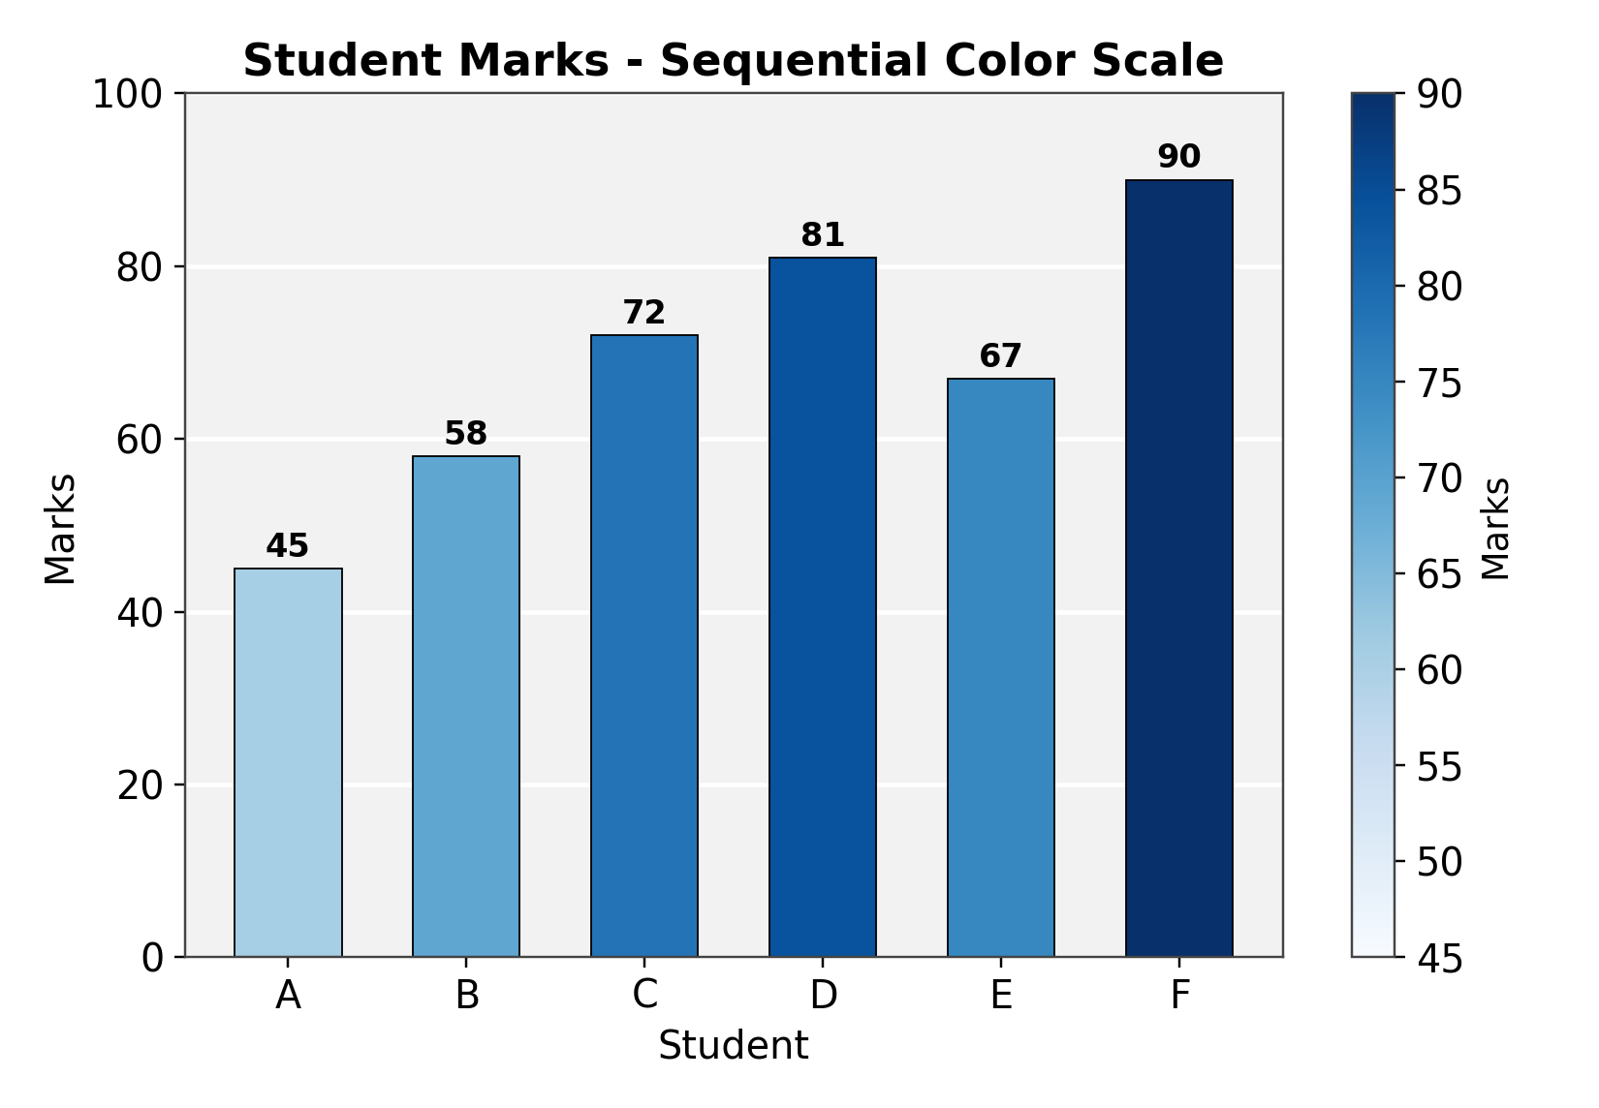
Fig 3.1: Bar chart of student marks using a sequential color scale
Answers:
Identify the students with the highest and lowest marks from the visualization.
From the chart, the darkest bar belongs to Student F with 90 marks, making it the highest scorer, while the lightest bar belongs to Student A with 45 marks, the lowest scorer. The gradient from light to dark blue makes it possible to identify these extremes at a glance, even before reading the exact numbers on the bars.
Explain why a sequential color scale is appropriate.
Marks is a continuous, ordered numeric variable where higher values represent better performance, so a sequential colour scale -- which progresses smoothly from a light shade to a dark shade of the same hue -- is appropriate because it visually encodes this natural ordering. A viewer can intuitively read darker bars as higher marks without needing a separate legend for each individual value, which would not work as well with an unordered, qualitative colour scheme.
Suggest a color palette suitable for color-blind users.
Palettes such as Viridis, or the ColorBrewer sequential palettes like 'Blues' or 'YlGnBu', are good choices for colour-blind accessibility. These palettes are specifically designed so that the perceived brightness changes smoothly and consistently across the scale, which keeps the values distinguishable for people with red-green or blue-yellow colour vision deficiencies, unlike palettes that rely purely on hue differences.
Explain the difference between sequential and categorical color scales.
A sequential colour scale uses varying shades of a single hue (light to dark) to represent an ordered, continuous variable, where the position along the gradient conveys magnitude, as with Marks in this example. A categorical (or qualitative) colour scale, by contrast, uses visually distinct, unrelated hues -- such as red, blue, and green -- to differentiate between groups that have no inherent order, like Category or Region in the other questions in this assessment. Using a sequential scale for categorical data (or vice versa) would mislead viewers into perceiving an order or magnitude that does not exist.

Question 4: Highlighting with Color
R Program:
library(ggplot2)

revenue_data <- data.frame(
Region = c("North","South","East","West","Central"),
Revenue = c(820, 760, 790, 1010, 770)
)
revenue_data$Highlight <- ifelse(revenue_data$Revenue == max(revenue_data$Revenue),
"Highest", "Other")

ggplot(revenue_data, aes(x = Region, y = Revenue, fill = Highlight)) +
geom_bar(stat = "identity") +
scale_fill_manual(values = c("Highest" = "firebrick", "Other" = "grey70")) +
labs(title = "Regional Revenue - Highest Highlighted") +
theme_minimal()
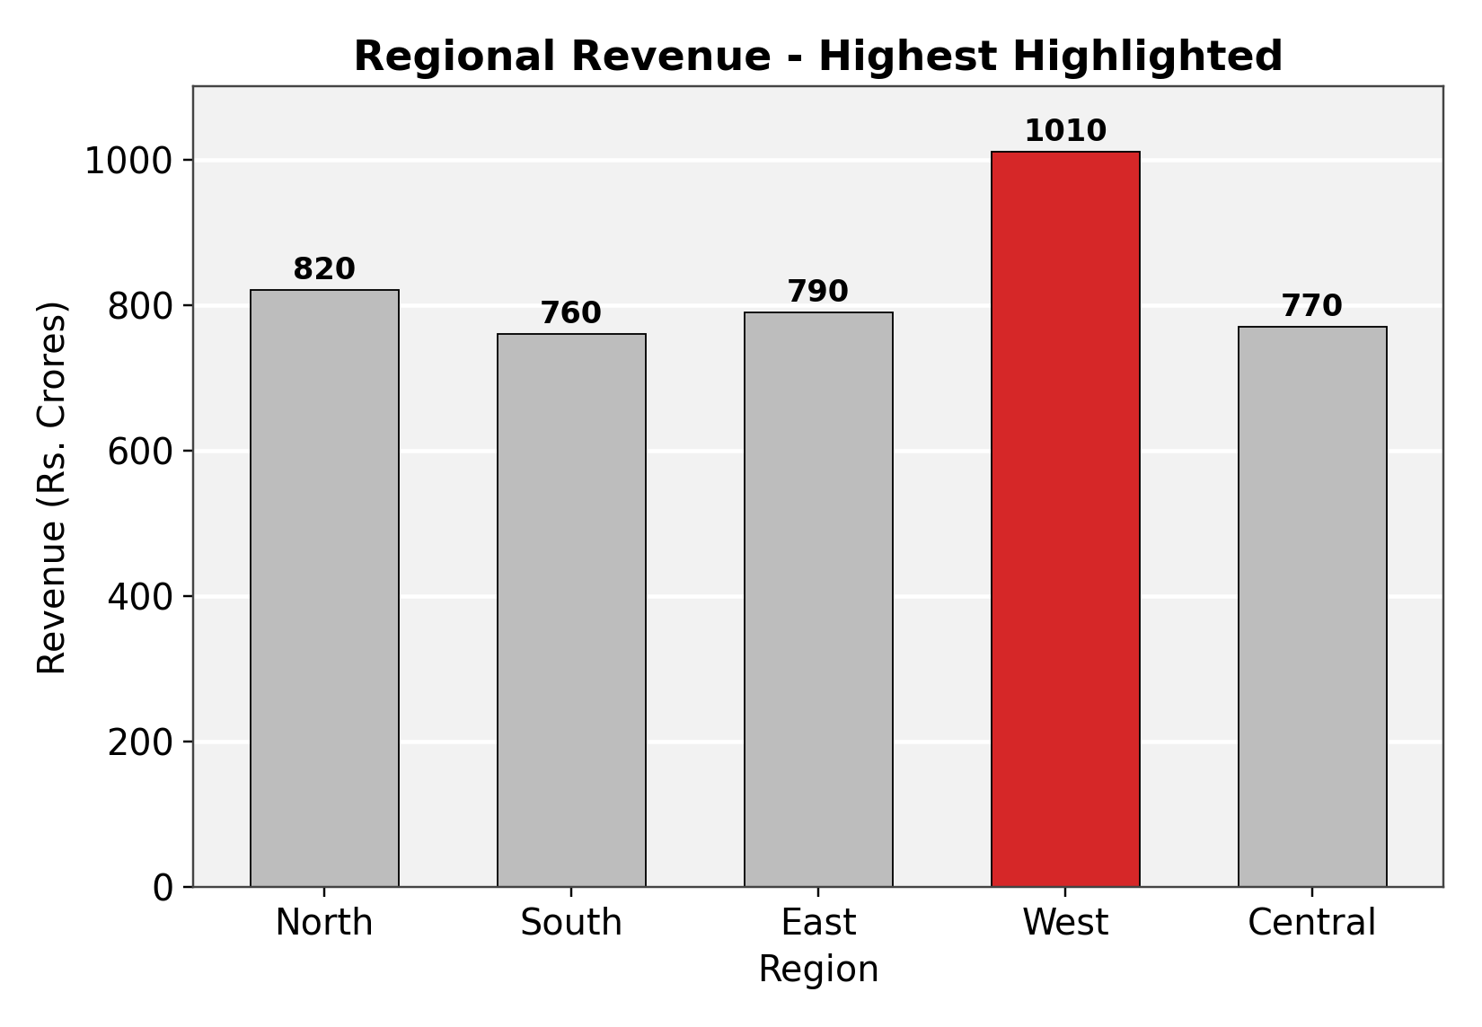
Fig 4.1: Bar chart with the highest-revenue region highlighted
Answers:
Explain how highlighting improves data interpretation.
Highlighting improves data interpretation by immediately drawing the viewer's attention to the single most important value in the chart, without requiring them to compare every bar manually. By keeping all other bars in a neutral grey and reserving a strong, distinct colour for only the highest region, the chart guides the eye directly to the key insight -- which region leads in revenue -- reducing the cognitive effort needed to extract that conclusion from the data.
Identify the highest-performing region.
The West region is the highest-performing region, with a revenue of Rs. 1010 Crores, noticeably ahead of the next closest region, North, at Rs. 820 Crores.
Discuss how excessive use of colors can affect interpretation.
When too many distinct colours are used across a chart, every bar or category competes equally for the viewer's attention, which defeats the purpose of highlighting and makes it harder to tell which value is actually significant. Excessive colour variation can also introduce unintended visual hierarchies or associations (for example, red often implies danger or a negative outcome), potentially misleading viewers about the meaning of the data rather than simply marking out the value of interest.
Suggest one alternative highlighting technique other than color.
Instead of colour, the highest bar could be highlighted using a direct data label or annotation -- for instance, displaying the exact revenue value in bold text above the bar, or adding a small arrow or star marker pointing to it. Other options include making the bar's outline thicker, slightly increasing its width, or adding a subtle drop shadow, all of which draw attention to the bar's shape or position rather than relying on colour.

Question 5: Integrated Visualization
R Program:
library(ggplot2)

city_data <- data.frame(
City = c("A","B","C","D","E"),
Population = c(8.2, 5.6, 9.4, 6.8, 4.9),
AQI = c(110, 180, 90, 240, 150),
Rainfall = c(850, 430, 1200, 520, 680),
Region = c("North","South","North","East","West")
)

ggplot(city_data, aes(x = Population, y = AQI,
size = Rainfall, color = Region)) +
geom_point(alpha = 0.85) +
labs(title = "Population vs AQI (Bubble size = Rainfall)",
x = "Population (Million)", y = "AQI") +
theme_minimal()
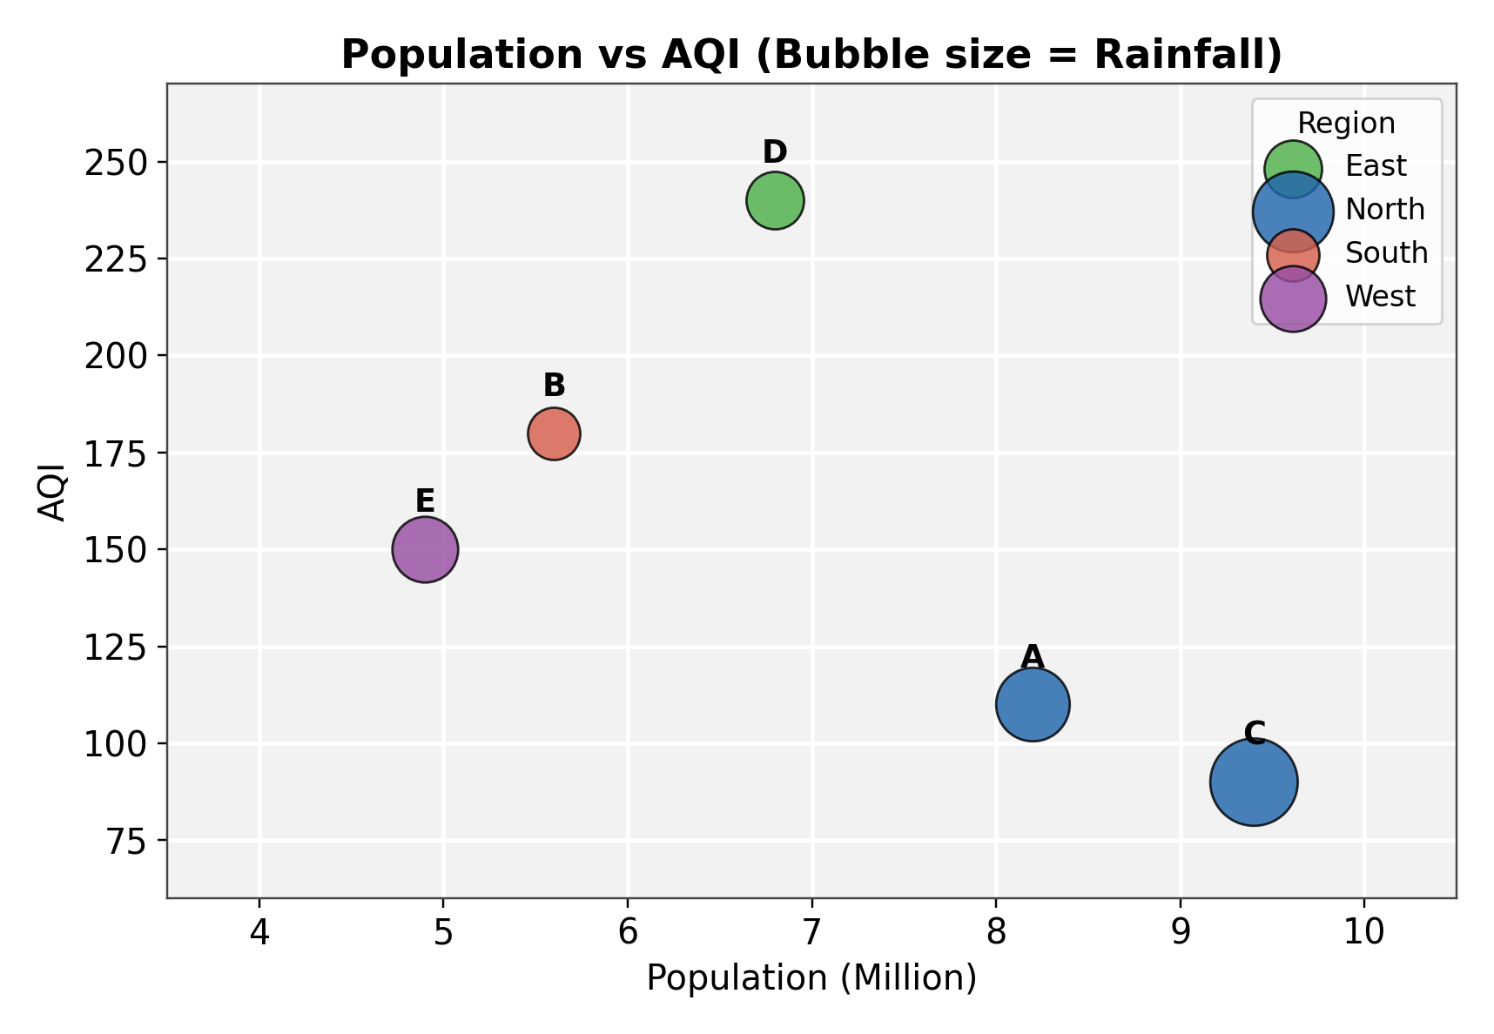
Fig 5.1: Bubble chart of Population vs AQI, sized by Rainfall and colored by Region
Answers:
Select suitable aesthetics for Population, AQI, Rainfall, and Region.
Population is mapped to the x-axis and AQI to the y-axis, since both are continuous numeric variables well suited to positional encoding. Rainfall is mapped to bubble size, allowing a third continuous variable to be represented without needing another axis. Region is mapped to colour, since it is a categorical variable with only four distinct groups, making colour an effective way to distinguish them without confusion.
Interpret the relationship between Population and AQI.
There is a generally positive relationship between Population and AQI in this dataset: City D, with the second-highest population (6.8 million), has by far the highest AQI (240), and City B (5.6 million) also shows an elevated AQI (180). In contrast, City C, the most populated city (9.4 million), has the lowest AQI (90), which stands out as an exception to the overall trend -- likely because it also receives the highest rainfall (1200 mm), which may help disperse pollutants and improve air quality despite the large population.
Identify the continuous and categorical variables.
Population, AQI, and Rainfall are all continuous variables, since each can take a wide range of numeric values. Region is the categorical variable, as it consists of a fixed set of labels (North, South, East, West) with no inherent numeric order.
Recommend one improvement to enhance the visualization's readability.
Adding direct city-name labels next to each bubble, as shown in the chart above, improves readability by letting viewers identify individual cities immediately without cross-referencing a separate key. A further improvement would be to add a size legend explicitly showing what bubble sizes correspond to specific rainfall values (e.g., 500 mm, 1000 mm), so that the magnitude of the third variable can be read quantitatively rather than only compared relatively between bubbles.

